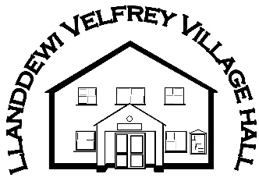

Llanddewi Velfrey Village Hall

List of Local caterers

* The Plum Tree – Matthew Webb, 01834 831863 / Theplumtree2016@outlook.com
* Becws Bets – Betsan Brockbank, becwsbets@outlook.com
* Hywel Dda Coffee Shop – Christine, 01994 240867 / christinemarie2604@outlook.com
* Lillies Coffee Shop – Chloe or Kathryn, 01834 861665 / chloebland21@outlook.com / Kathrynjames69@outlook.com
* The Yellow Honesty Shop - Whitland, thecakeshopwales@gmail.com
* Bakeaway – Janet Mathias, 01646 650132 / katymathias@hotmail.co.uk
* The Kitchen – Kate Richards 07974 682648 / thekitchenpembrokeshire@gmail.com

Please note that none of these caterers are in any way affiliated with the hall. We offer these details as a courtesy and for your convenience, we make no individual recommendation and take no responsibility for any contract between you and your chosen caterer.